**VISHWAKARMA INSTITUTE OF INFORMATION TECHNOLOGY, PUNE**

**COMPUTER ENGINEERING DEPARTMENT**

**APRIL-MAY 2018**

**Synopsis**



**Group number: BE Comp/PRJ/18-19/42**

**Group Members :**

**1. Dhiraj Warke dhiraj.warke.@viit.ac.in**

**2. Tasneem Naseem tasneem.naseem@viit.ac.in**

**3. Sakshi Patil sakshi.patil@viit.ac.in**

**4. Pratik Gare pratik.gare@viit.ac.in**

**Title :** Intelligent Lead Qualifier For Predicting MQL

**Objective :** To provide Most Qualified Leads (MQL) to the Sales Executives and the courses customers will be interested in ,also sends SMS/Mails to the customers in real time .

**Abstract :** Intelligent Lead Qualifier is a machine learning black box that provides suggestions of leads to the Sales Executives also known as Most Qualified Leads (MQL).

Our Intelligent Lead Qualifier is a component of a larger system which is a cloud based telemarketing software to easily manage all your outbound calling, Live call reports, call recordings, lead management and follow up.

The application integrates our system to main web application as a web service.Our system helps existing larger system to increase in usage of system by accurate predictions of Leads and the courses they will be interested in.

**Briefs about Contents:**

1. **Introduction :**

The Lead Prediction system is a Prediction Black Box for

predicting Most Qualified Leads (MQL) intelligently.

The Prediction system makes use of the student or customer data to predict whether the particular student will be a Hot, Warm or Cold Lead and which course he/she will be interested in, based on their attributes from the dataset such as skills,Qualification, Location,College,etc.

And Also Sending the customer messages or emails in real time.This type of filtering is based on collecting and analyzing student information.

1. **Technical Details :**

The lead qualifier will be integrated with the cloud based telemarketing software that Felix-Its uses that is basically an web application. The software for the Prediction subsystem will be written in python, using Pycharm. The subsystem will run off a Cloud-Based Platform.

The UI part of this component will be done using PHP OR Angular JS. The Cloud-based server will utilize Oracle or SQL database running on the cloud.Integration to the server shall be done via a HTTP.

1. **Working :**

* Sales Executive/Manager feed the student Info to the Lead Qualifier Black Box.

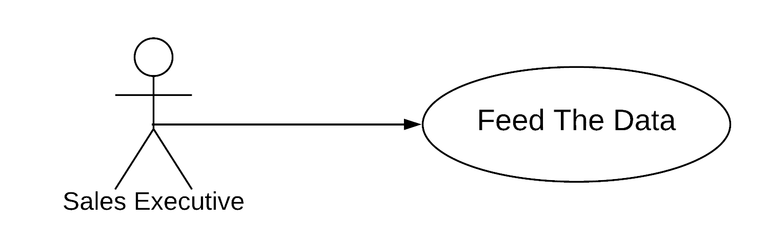

* Sales Executive/Manager shall see/check for the customer if he is present in the in the database from first.
* Sales Executive will get the predictions in terms of Leads an Interested courses.

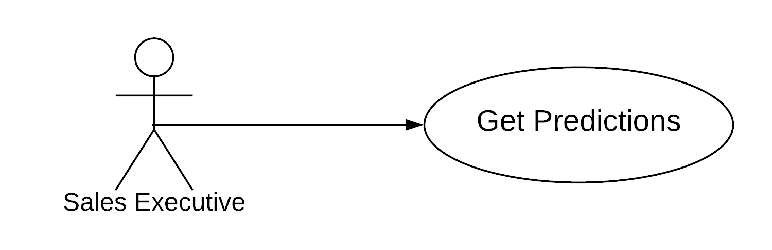

* Sales Executive can call/sms/Mail the Leads .

1. **Applications:**

The Lead Qualifier System predicts :

1. Hot,Warm leads
2. Courses that student will be interested in.
3. Send Message/Emails to Hot Leads in Real Time.

The application integrates our system to main web application as a web service.Our system helps existing larger system to increase in usage of system by accurate predictions of Leads and the courses they will be interested in.

The mails And messages will be sent in real time to the customer increasing the customer engage.

**References/Bibliography:**

[1] Bishop, C. M. (1995). Supervised Machine Learning Algorithms: Classification and Comparison. Clarendon Press, Oxford, England. 1995. Oxford University Press, Inc. New York, NY, USA ©1995 ISBN:0198538642 Available at: http://cs.du.edu/~mitchell/mario_books/Supervised Machine Learning Algorithms: Classification and Comparison